**Saint Brigid Saint John the Baptist**

The Epiphany of

the Lord

January 7, 2018

**Catholic Church Catholic Church**

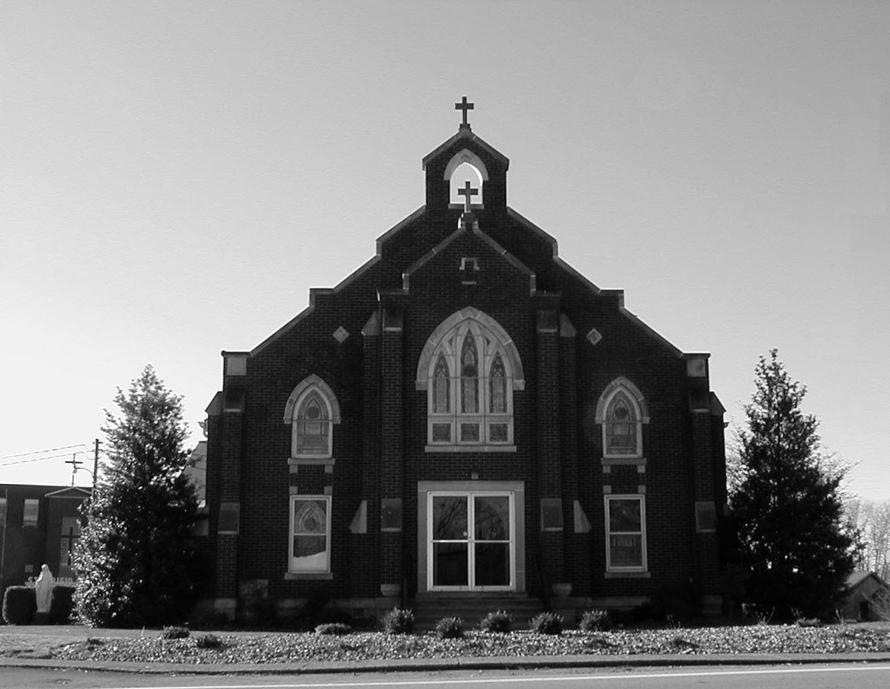

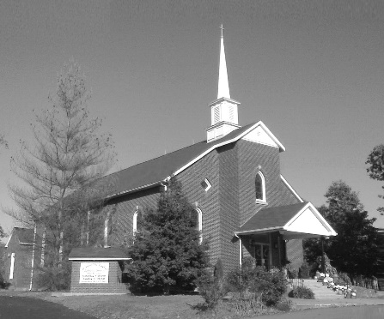

**Pastor:**

***Rev. Daniel L. Lincoln***

Rectory: (270) 877-2546

**Deacon:**

**Michael A. Ryan**

(270) 272-6789

314 E. Main St. 657 St. John Church Rd.

Vine Grove, KY 40175 Elizabethtown, KY 42701

Clustered Parish Office: Clustered Parish Office:

(270) 877-2461 (270) 877-2461

**ANNOINTING OF THE SICK:**

Notify the parish office when a family member is hospitalized.

**BAPTISM:**

Contact the parish office for information about the required preparation class.

**BULLETIN:**

Information must be submitted in writing by note or email to the parish office **no later than 12:00 noon on Wednesdays** for the following weekend. When sending an email, please put “BULLETIN,” and the name of the parish the announcement is for, in the subject line.

**MARRIAGE:**

Contact Father at least 6 months prior to the wedding date to complete required marriage preparations and to schedule the date.

**RCIA (Rite of Christian Initiation of Adults):**

Contact the Worship Chairperson for information.

**DEW MEMORIAL LIBRARY:**

(in St. Brigid Church basement):

Open: Sunday after 9:30 a.m. Mass& 45 minutes before all other Masses.

Email: [brigidvg@bbtel.com](mailto:brigidvg@bbtel.com)

Website:[www.stbrigidvg.org](http://www.stbrigidvg.org)

**Pastoral Associate & Dir. Dir. of Religious Education:**

**of Religious Education:** Lisa Thomas: (270) 735-6930

Deacon Mike Ryan (270 877-0546

**Youth Minister: Youth Ministers:**

Lori Law: (270) 723-0157 Angela Churchman:

(270) 268-9963

Ericka Finlay: (502) 612-2644

**MASS SCHEDULE:**

*Sunday:* 9:30 a.m. & 6:30 p.m.

*Monday:* 9:00 a.m.

*Thursday:* 9:00 a.m.

**RECONCILIATION:**

Sunday before Mass

5:30-6:00 p.m. or by appt.

**ROSARY:**

After weekday Masses

**PARISH COUNCIL MEMBERS:**

*President:* Sue Weisshaupt

*Vice-President:* Mike Bramlett

*Secretary:* Judy Cochran

*At-Large Members:* Blake Ryan

& Vincent Thompson

**CHAIRPERSONS:**

*Administration:* Dale Winchester

*Formation:* Tina Yates

*Parish Life:* Tom Billings

*Worship:* Keith Baughman

**MASS SCHEDULE:**

*Saturday (Vigil):*  6:30 p.m.

*Sunday:* 11:30 a.m.

*Wednesday:* 6:30 p.m.

*Friday:* 9:00 a.m.

**RECONCILIATION:**

Saturday before Mass

5:30-6:00p.m. or by appt.

**PARISH COUNCIL MEMBERS:**

*President:* Theresa Smith

*Secretary:* Karen Ray

**CHAIRPERSONS:**

*Administration:* Rick Newton

*Formation:* Ericka Newton

*Parish Life:* Bradley Wickersham

*Worship:* Nick Thomas



**Mass Schedule**

**Mass Schedule**

|  |  |  |  |  |  |
| --- | --- | --- | --- | --- | --- |
| **Saturday** | **January 6** | **6:30 p.m.** | **St. John** | **For All Parishioners** | **Vigil: The Epiphany of the Lord** |
| **Sunday** | **January 7** | **9:30 a.m.** | **St. Brigid** | **Our Parish Family**  **Carlos Robbins** | **The Epiphany of the Lord** |
| **“** | **“** | **11:30 a.m.** | **St. John** | **Sid Vessels** | **“** |
| **“** | **“** | **6:30 p.m.** | **St. Brigid** | **Billy Cecil** | **“** |
| **Monday** | **January 8** | **9:00 a.m.** | **St. Brigid** | **Dickie Cecil** | **The Baptism of the Lord** |
| **Wednesday** | **January 10** | **6:30 p.m.** | **St. John** | **For Special Intentions** | **Weekday** |
| **Thursday** | **January 11** | **9:00 a.m.** | **St. Brigid** | **Dorothy Hulsman** | **Weekday** |
| **Friday** | **January 12** | **9:00 a.m.** | **St. John** | **Bruce & Margaret Lincoln** | **Weekday** |
| **Saturday** | **January 13** | **6:30 p.m.** | **St. John** | **Phillip Thomas** | **Vigil: 2nd Sunday in Ordinary Time** |
| **Sunday** | **January 14** | **9:30 a.m.** | **St. Brigid** | **Harold Yates** | **2nd Sunday in Ordinary Time** |
| **“** | **“** | **11:30 a.m.** | **St. John** | **For All Parishioners** | **“** |
| **“** | **“** | **6:30 p.m.** | **St. Brigid** | **Our Parish Family**  **George Weeks** | **“** |

**INFORMATION FOR BOTH PARISHES**

**MERRY CHRISTMAS** – May this Christmas Season bring you and your loved ones God’s gifts of peace, comfort and joy! Fr. Dan and Deacon Mike.

**PARISH GUIDE BOOK & DIRECTORY** – For future updates, please be sure to call the office at (270) 877-2461 if you address, phone or email changes.

**MASS INTENTIONS** – It is the beginning of a new year and Mass intentions are always needed. Plan now for your requests for the coming year and schedule early, especially if you want a specific date. Always remember, however, that dates may have to be rescheduled due to funerals, retreats, etc. Thank you for your understanding.

**CONFIDENTIAL PREGNANCY AND ADOPTION COUNSELING** – is available at Catholic Charities for women of all ages experiencing untimely pregnancies. A full range of services are provided, including adoptive placement, legal assistance and counseling for individuals, groups and families. Post-abortion counseling is also available. Services are provided regardless of income or marital status. For more information, call Catholic Charities at (502) 637-9786.

**PROJECT RACHEL** **–** Healing…Forgiveness…Hope…After the experience of an abortion. If you or someone you know is struggling with the pain from an abortion, please consider Project Rachel – a post abortion ministry. To speak to someone confidentially, call (502) 471-2155 or email [ProjectRachel@archlou.org](mailto:ProjectRachel@archlou.org).

**ROOM IN THE INN** – is a local community-based effort to help the homeless. If you are interested in this ministry, please take one of the letter/forms in the church lobby or call Betty Smith at (270) 769-3775. For more information, please contact Silvia Love at (831) 431-3293 or Silvia.h.love@gmail.com. *"Whatever you have done to one of the least of my brothers, you have done to me."* Matthew 25:40

**ARCHDIOCESAN WEDDING ANNIVERSARY MASS 2018** – Couples celebrating 5, 10, 15, 20 & 25 years of marriage in 2018 and their families are invited to attend a special Archdiocesan Mass of Thanksgiving, celebrated by Archbishop Joseph Kurtz. The event will take place on **Saturday, January 20, 2018** at **4:00 p.m.** at **St. Raphael Parish**, 2900 Bardstown Road. Call your parish secretary to register. **Registration deadline is Wednesday, January 10, 2018.**

* * * * * * * * * * * * * * * * * * * *

**St. John and St. Brigid Prayer List**

To add someone to the prayer list, please call the parish office at (270) 877-2461. **Remember to call to remove someone from the list if they are no longer sick, etc.** *Please note that the prayer list has been revised. It is primarily for parishioners and their immediate family members*.

Helen “Dinky” (Cowley) **Adams**, Sam **Adams**, April **Allen**, Dennis **Arnold**, Barbara **Ashley**, Sue **Banks**, Shannon **Barnes,** Denise **Barnett**, the **Bigler** family, Timothy **Birch**, Teresa **Laycock**, Charlie **Bowers**, Wanda **Branson**, Bill **Brown**, Ellen **Bryan**, Richard **Bryson**, Carol **Buchanan**, Jeremy & Margie **Buyer**, Ashley **Butler**, Deacon Bob **Caspar**, Sue **Caswell**, Ed **Cecil**, J. Mack **Cecil**, Harlan Ford **Clark**, John **Connor**, Betty Jo **Cooper**, Heidi **Correa**, Jeff **Craig**, Glynn **Clutches**, Roan **Dowell**, Karen **Dworshak**, Leroy **Embry**, Dwayne **Garcia**, Carrie **Gribben**, Mary **Hager**, Mrs. Charles **Hair**, Stephanie **Hall**, Donnie **Hart**, Jimmy **Harper**, Bobby **Harris**, Debbie **Hodge**, Richard **Hughes**, Betty Lou **Jones**, Andrew **Kieta**, Jenny **Leonhardt**, Jackie **Long**, Louise **Lucous**, Alma **Mahanna**, Shelly **Martin**, Shirley **Martin**, Martina **Masoni**, Don **Mattingly**, Paul Michael **Mattingly**, Mary **Medley,** Cindy **Miller**, Starla **Miller**, Doug **Osborne**, Bernard **Osborne**, Duane **Osborne**, Mickey **Padgett**, Frank **Inanely**, Annie **Pierce**, Adrianna **Porter**, Jeremy **Porter**, Allie **Ray**, Mary Agnes **Ray**, Mary Ellen **Ray**, James S. **Reed**, Tonya **Reisinger**, Joel **Rivera**, Caroline **Seabee**, Bruce **Sherrard**, Ralph **Staples**, Joan **Stith**, Keith **Tassin**, Eric **Taylor**, Anthony **Thomas**, Kenny **Thompson**, Charles **Tucker,** Raffaella **Tucker**, Debi **Turner**, Charlotte **Vowels**, Bill **Waldrop**, Lois **Weaver**, Paul A. **Whelan**, Jennifer **Williams**, Sandy **Wiseman**, Zach **Wiseman**, Gail **Wilson**, Don **Wooldridge**, Connor **Wright**, Rose Marie **Yates** and all the sick.

* * * * * * * * * * * * * * * * * * * *

**Our Military List**

To add someone to the military list, please call the parish office at (270) 877-2461. **Remember to call to remove someone from the list if they are no longer in the service**.

Lt. Matt **Bednar**, A1C Brandon **Davila**, SrA Felicia **Esquivel**, A1C Ryan **Henley**, A1C Joseph **Manco**, SPC Jacob L. **Nall**, SFC Peter **Novak**, Tony **Rickerl**, Lt. Col. Paul **Rigby**, James **Rogers**, Tony **Rogers**, Jonathon **Sifford**, Jeffrey **Slade**, Derek **Smith**, CSM Vance **Snider**, Brian **Tomassi**, A1C Daniel **Trombone**, SGT Evan **Vaughan**, Lisa **Flynn-Veri**, LT Michael **Veri**, LTC Steve **Wickersham**, SGT Clay **Wilson**, TSGT Jeremy **Yates**, Austin **Zulka** and for all who serve and have served our country.

**Rite of Christian Initiation for Adults (RCIA)**

**Date: Tuesday, January 9, 2018** **Topic:** The Sacrament of Penance & Reconciliation [C5]

Sacrament of the Sick [C6]

**Facilitator:** Deacon Mike Ryan

Anyone interested should contact Keith Baughman at (270) 877-5283 or the Parish Office at (270) 877-2461. Leave your name and phone number.

**ST. JOHN THE BAPTIST CATHOLIC CHURCH INFORMATION**

**Monthly Budget Amount Needed:** $ 12,500.00

**Monthly Collection for November:** $ 10,746.20

**Monthly Collection for December:** $ 15,631.35

**FR. STAN OSBORNE** – can be reached at Nazareth Home, Room 112, 2000 Newburg Rd., Louisville, KY 40205.

**WELCOME PACKETS** – If you would like to become a member, or learn more about St. John Parish, please take a *Welcome Packet* in the church lobby. You may return the census card and the stewardship form to Father Dan or place in the collection basket.

**CATHOLIC SERVICES APPEAL** – $20,795 – 95% of our financial goal; 91 of 98 families – 93% of participation goal. Our parish goal this year is $21,900. Our parish participation goal is 98 families. There are extra donation forms in the church lobby. Thank You! to everyone who participated. Thank You! To everyone who participated.

**HABITAT FOR HUMANITY** – Thanks St. John friends for the items donated to the Murley house that was dedicated on Sunday, December 10. Your gifts of cookware, silverware, stoneware, baking pans, towels and other items were greatly appreciated by this first-time home owner. Your generosity has blessed 17 homes to date. The Habitat Community is thankful for your continued support.

**PARISH COUNCIL** – will meet on **Monday, January 15, at 6:30 p.m.** in the Parish Hall.

* * * * * * * * * * * * * * * * * * * *

**Religious Education**

**Classes will resume on Sunday, January 7, 2018 from 9:45 to 11:00 a.m.** Start the new year off right with a family resolution to make Religious Education classes a priority for the new year.

**First Reconciliation:** Our 2nd grade class will be celebrating the Sacrament of Reconciliation on **Wednesday, January 10, 2018 at 6:00 p.m.** prior to the 6:30 p.m. Mass. Please keep these students, their families and their teachers in your prayers as they prepare for this Sacrament and the next step in their faith life journey.

Any questions, contact Lisa Thomas at (270) 735-6930 or glalt@comcast.net.

* * * * * * * * * * * * * * * * * * * *

**St. John Liturgical Ministers**

|  |  |
| --- | --- |
| **Vigil: 2nd Sunday in Ordinary Time, January 13, 2018, 6:30 p.m.** |  |
| Extraordinary Ministers of the Eucharist | Joanna Sherrard Abby Newton Rhonda Newton |
| Lector | Tony Smith |
| Servers | Volunteers |
| Greeter(s) | Rhonda Newton |
| Gift Bearers | Newton Family |
| Ushers | John Thomas Kenny Heibert |
| **2nd Sunday in Ordinary Time, January 14, 2018, 11:30 a.m.** |  |
| Extraordinary Ministers of the Eucharist | Lucy Ramos Martha Thomas Scott Mattingly |
| Lector | Clarissa Yates |
| Servers | Olivia Leasor Rilee Leasor |
| Greeter(s) | Updegraff Family |
| Gift Bearers | Aimee Hunt & Family |
| Ushers | Trent Thomas Joe Samu |
| **Hospital Ministry – Sunday, January 28, 2018** | Marcella Brangers & Sharon Reed |

**ST. BRIGID CATHOLIC CHURCH INFORMATION**

**Monthly Budget Amount Needed:** $ 25,280.00

**Monthly Collection for November:** $ 24,349.59

**Monthly Collection for December:** $ 37,419.72

**St. Vincent de Paul for December:** $ 700.00

**WELCOME VISITORS** – If you are interested in joining our parish, please pick up a Welcome Packet at the church doors. Complete the registration form and either drop it in the collection basket or mail it to the office. If you just need to update your registration, there are also forms available.

**CATHOLIC SERVICES APPEAL** – $34,055 – 103% of our financial goal; 116 of 136 families – 85% of participation goal. Our parish goad this year is $33,100. Our parish participation goal is 136 families. There are extra donation forms in the church lobby. Thank You! to everyone who participated. Thank You! To everyone who participated.

**CONGRATULATIONS** – Archbishop Kurtz says, “Thank You!” for your generosity. We have surpassed our financial goal for Catholic Services Appeal 2017!!

**ALTAR SERVER SCHEDULES** – New server schedules will not go out until after server training on January 7, 2018. We need servers to volunteer until the schedules are sent out the week of the January 7. Any questions should be directed to Deacon Mike. Our head altar servers, Emily Chandler and Molly Weisshaupt, can also answer any questions you may have. Do you hear the call to serve? Listen!!!

**ALTAR SERVER TRAINING** – Anyone who has been baptized and received First Communion can become an altar server. There will be altar server training on **Sunday, January 7, 2018** after the 9:30 a.m. Mass. This training is for all ages from third grade to adult.

**PARISH COUNCIL** – will meet on **Thursday, January 18, at 7:00 p.m.**

* * * * * * * * * * * * * * * * * * * *

**St. Brigid Youth Ministry**

**Friday, January 12** – Christian Awakening Junior Retreat! Any junior interesting in going please contact Lori.

If you have any questions, please contact Lori at (270) 723-0157 or email at [stbrigidyouth@hotmail.com](mailto:stbrigidyouth@hotmail.com).

**St. Brigid Monthly Meet and Greet**

St. Brigid Parish hosts a “Meet and Greet” downstairs the 2nd Sunday of each month immediately following the 9:30 a.m. Mass with coffee and donuts. This is a great opportunity for existing parishioners to extend a warm welcome to visitors and anyone interested in joining St. Brigid Parish. Be sure to also visit the Dew Memorial Library.

**The next Meet and Greet will be Sunday, January 14, 2018.**



**Faith Formation**

***“Soup-er Bowl”***

Come get in the game! Celebrate Souper Bowl with us at the Souper-supper!

Date: **Sunday, January 28, 2018**

Time: **4:00-6:00 p.m.**

Place: **Catholic Community Center**

Bring your favorite soup in a crockpot and we’ll keep it hot! Try a cup of one soup or ALL if you please!

**Sign-up sheets will be at the doors of the church.** Questions? Call Selina Chandler at (270) 765-3672

**St. Brigid Liturgical Ministers**

|  |  |
| --- | --- |
| **2nd Sunday in Ordinary Time, January 14, 2018, 9:30 a.m.** |  |
| Extraordinary Ministers of the Eucharist P. | Danny Board Angie Bragg |
| C. | Helen Hicks Tina Yates Janey Jenkins E. Jane Vessels |
| Lector | Tina Yates |
| Servers | Volunteers |
| Greeters | Tina Yates Chris & Janet Kennedy |
| **2nd Sunday in Ordinary Time, January 14, 2018, 6:30 p.m.** |  |
| Extraordinary Ministers of the Eucharist P. | Keith Baughman |
| C. | Ashley Osterhage Linda Rogers |
| Lector | Tyler Hall |
| Servers | Volunteers |
| Greeters | Volunteers |
| **Hospital Ministry – Sunday, January 14, 2018** | Keith Baughman & Jim Klimesh |

*Marriage Moments –*

Ways to Turn Your Spouse Off #7 – Let Lists Rule Your Life. It’s the season of New Year’s Resolutions. This can be good, but it can also turn your focus away from your spouse to self-improvement. Today, make one specific Resolution to deepen your love.

* * * * * * * * * * * * * * * * * * * *

*Parenting Pointers* –

The Feast of the Epiphany is when Christians celebrate the 3 wise men’s (foreigners) search for God. Legend has it that they followed a star. Gazing at stars can be a mystical experience. Look up at the sky with your child tonight. Hopefully you will see stars. Ponder the Universe together.

